## Working Papers

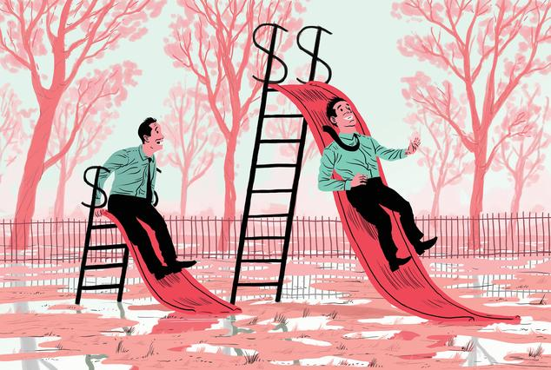

**How Much Does Your Boss Make?**

Do employees know how much more they bosses get paid? Are employees demotivated by this inequality? To address these questions, we conducted a field experiment with 2,060 employees from a multibillion-dollar corporation.

Cullen, Z. and Perez-Truglia, R. (2018). How Much Does Your Boss Make? The Effects of Salary Comparisons. NBER Working Paper No. 24841. [Revise & Resubmit, Journal of Political Economy]

[[PDF]](https://www.ocf.berkeley.edu/~pereztruglia/assets/how_much_does_your_boss_make.pdf)



**The Old Boys' Club**

Using administrative data and an event-study design, we provide causal evidence that employees’ social interactions with their managers can be advantageous for their careers and that this phenomenon contributes to the gender pay gap.

Cullen, Z. and Perez-Truglia, R. (2019). The Old Boys' Club: Schmoozing and the Gender Gap. NBER Working Paper No. 26530.

[[PDF]](https://www.ocf.berkeley.edu/~pereztruglia/assets/the_old_boys_club.pdf)

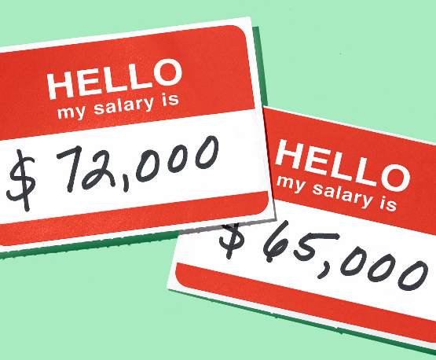

**The Salary Taboo**

Access to salary information is believed to be limited and unequal, but there is little direct evidence on the sources of these information frictions. We provide evidence on the role of privacy norms with a field experiment involving 755 employees from a multibillion-dollar corporation.

Cullen, Z. and Perez-Truglia, R. (2018). The Salary Taboo: Privacy Norms and the Diffusion of Information. NBER Working Paper No. 25145.

[[PDF]](https://www.ocf.berkeley.edu/~pereztruglia/assets/the_salary_taboo.pdf)

**Betting on the House**

Home price expectations play a central role in macroeconomics and finance. However, there is little direct evidence on how these expectations affect market choices. We provide unique evidence from a large-scale field experiment involving 57,910 homeowners in the United States.

Bottan, N. and Perez-Truglia, R. (2020). Betting on the House: Subjective Expectations and Market Choices. NBER Working Paper No. 27412.

[[PDF]](https://www.ocf.berkeley.edu/~pereztruglia/assets/betting_on_the_house.pdf)

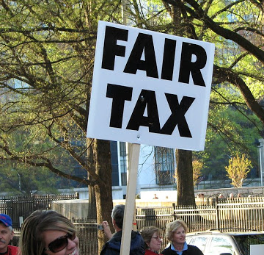**My Taxes are Too Darn High**

Households can file a protest with the goal of legally reducing their property taxes. This choice provides a unique opportunity to study support for taxation via revealed preference. We study the motives driving tax protests through two sources of causal identification: a quasi-experiment and a pre-registered large-scale natural field experiment.

Nathan, B.; Perez-Truglia, R. and Zentner, A. (2020). My Taxes are Too Darn High: Tax Protests as Revealed Preferences for Redistribution. NBER Working Paper No. 27816.

[[PDF]](https://www.ocf.berkeley.edu/~pereztruglia/assets/my_taxes_are_too_darn_high.pdf)

**Tax Audits as Scarecrows**

To study tax evasion choices, we conducted a large-scale field experiment with 20,440 small- and medium-sized firms that collectively paid more than 200 million dollars in taxes per year. Our evidence suggests that audits may deter tax evasion in the same way that scarecrows frighten off birds.

Bergolo, M.; Ceni, R.; Cruces, G.; Giaccobasso, M. and Perez-Truglia, R. (2017). Tax Audits as Scarecrows: Evidence from a Large-Scale Field Experiment. NBER Working Paper No. 23631. [Revise & Resubmit, American Economic Journal: Economic Policy]

[[PDF]](https://www.ocf.berkeley.edu/~pereztruglia/assets/tax_audits_as_scarecrows.pdf)

**Your Place in the World**

Some of today’s most heated policy debates about Brexit, trade wars, climate change abatement, and migration involve redistribution of resources between countries. We study the demand for global redistribution using a two-year, face-to-face survey of a representative sample of German households

Fehr, D.; Mollerstrom, J. and Perez-Truglia, R. (2019). Your Place in the World: The Demand for National and Global Redistribution. NBER Working Paper No. 26555. [Revise & Resubmit, American Economic Journal: Economic Policy]

[[PDF]](https://www.ocf.berkeley.edu/~pereztruglia/assets/your_place_in_the_world.pdf)

**What Makes a Tax Evader?**

Why do some individuals choose to evade taxes while others do not? One popular view is thatsome individuals cheat on their taxes because they are more dishonest, selfish, or perceive different social norms. There is, however, little direct evidence on this matter. We address this question using a combination of surveys and administrative records.

Bergolo, M.; Leites, M.; Perez-Truglia, R. and Strehl, M. (2020). What Makes a Tax Evader? NBER Working Paper No. 28235.

[[PDF]](https://www.ocf.berkeley.edu/~pereztruglia/assets/tax_evader.pdf)

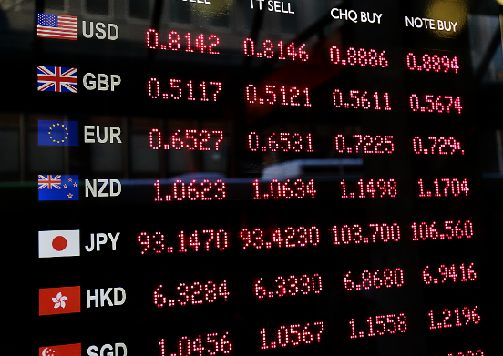**Macroeconomic Expectations and Credit Card Spending**

How do macroeconomic expectations affect consumer decisions? We examine this question using a natural field experiment with 2,872 credit card customers from a large commercial bank. We provide subjects with information about the future inflation rate and nominal exchange rate and measure the effects on spending.

Galashin, M.; Kanz, M.; Perez-Truglia, R. (2020). Macroeconomic Expectations and Credit Card Spending. NBER Working Paper No. 28281.

[[PDF]](https://www.ocf.berkeley.edu/~pereztruglia/assets/macro_credit_card.pdf)

**Are Political and Charitable Giving Substitutes?**

We provide evidence that individuals substitute between political contributions and charitable contributions. We use micro data from the American Red Cross and Federal Election Commission and exploit two natural experiments.

Petrova, M.; Perez-Truglia, R.; Simonov, A. and Yildirim, P. (2020). Are Political and Charitable Giving Substitutes? Evidence from the United States. NBER Working Paper No. 26616.

[[PDF]](https://www.ocf.berkeley.edu/~pereztruglia/assets/political_and_charitable_giving.pdf)

**Publications**

**The Effects of Income Transparency on Well-Being**

In 2001, Norwegian tax records became easily accessible online, allowing everyone in the country to observe the incomes of everyone else. We use survey data to provide evidence that the transparency policy increased the gap in happiness between richer and poorer individuals.

Perez-Truglia, R. (2020). The Effects of Income Transparency on Well-Being: Evidence from a Natural Experiment. American Economic Review, Vol. 110 (4), pp. 1019-54.

[[Link]](https://www.aeaweb.org/articles?id=10.1257/aer.20160256)  [[PDF]](https://www.ocf.berkeley.edu/~pereztruglia/assets/the_effects_of_income_transparency.pdf)  [[Slides]](https://www.ocf.berkeley.edu/~pereztruglia/assets/Slides_Norway.pdf)

**Choosing Your Pond**

Do individuals care about their relative income? Do they prefer to be a big fish in a small pond? We provide a unique test of this hypothesis based revealed-preference evidence from a field experiment with 1,080 senior medical students participating in the National Resident Matching Program.

Bottan, N. and Perez-Truglia, R. (2020). Choosing Your Pond: Location Choices and Relative Income. Review of Economics and Statistics, forthcoming.

[[PDF]](https://www.ocf.berkeley.edu/~pereztruglia/assets/chosing_your_pond.pdf)

**Expectations with Endogenous Information Acquisition**

We use a survey experiment to study how people select, acquire and process information. We find that, surprisingly, making information cheaper does not decrease the cross-sectional dispersion of expectations. We provide a model with costly acquisition and processing of information that can match most of our empirical results.

Fuster, A.; Perez-Truglia, R.; Wiederholt, M. and Zafar, B. (2020). Expectations with Endogenous Information Acquisition: An Experimental Investigation. Review of Economics and Statistics, forthcoming.

[[PDF]](https://www.ocf.berkeley.edu/~pereztruglia/assets/expectations_with_endogenous.pdf)

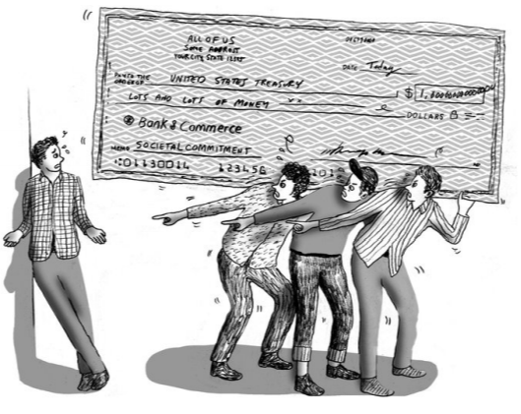

**Shaming Tax Delinquents**

Governments rely on shaming penalties to achieve policy goals, such as shaming tax delinquents. There is, however, little evidence on the effects of these policies. We provide evidence from a field experiment with 34,334 tax delinquents who owed a total of half a billion dollars in three U.S. states.

Perez-Truglia, R. and Troiano, U. (2018). Shaming Tax Delinquents. Journal of Public Economics, Vol. 167, pp. 120-137.

[[Link]](https://doi.org/10.1016/j.jpubeco.2018.09.008)  [[PDF]](https://www.ocf.berkeley.edu/~pereztruglia/assets/shaming_tax_delinquents.pdf)  [[Slides]](https://www.ocf.berkeley.edu/~pereztruglia/assets/Slides_Shaming_Tax_Delinquents.pdf)

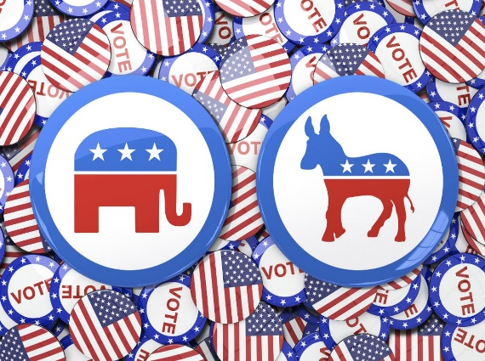**Political Conformity**

We provide causal evidence that individuals are more politically active in more like-minded social environments. We combine administrative data from the Federal Election Commission and the U.S. Postal Service and conduct an event-study analysis of the geographic mobility of 45,000 campaign contributors.

Perez-Truglia, R. (2018). Political Conformity: Event-Study Evidence from the United States. Review of Economics and Statistics, Vol. 100 (1), pp. 14-28.

[[Link]](https://doi.org/10.1162/REST_a_00683)  [[PDF]](https://www.ocf.berkeley.edu/~pereztruglia/assets/political_conformity.pdf)  [[Slides]](https://www.ocf.berkeley.edu/~pereztruglia/assets/Slides_Political_Conformity.pdf)

**Sympathy for the Diligent**

We present evidence from a survey experiment that individuals are more generous towards poor people whom they perceive to be diligent workers. This preference is much stronger than preferences regarding other characteristics of the poor, such as race, nationality, and disability. We show, theoretically and empirically, that the sympathy for the diligent generate a demand for workfare programs.

Drenik, A, and Perez-Truglia, R. (2018). Sympathy for the Diligent and the Demand for Workfare. Journal of Economic Behavior and Organization, Vol. 153, pp. 77-102.

[[Link]](https://www.sciencedirect.com/science/article/pii/S0167268118301744)  [[PDF]](https://www.ocf.berkeley.edu/~pereztruglia/assets/sympathy_for_the_diligent.pdf)

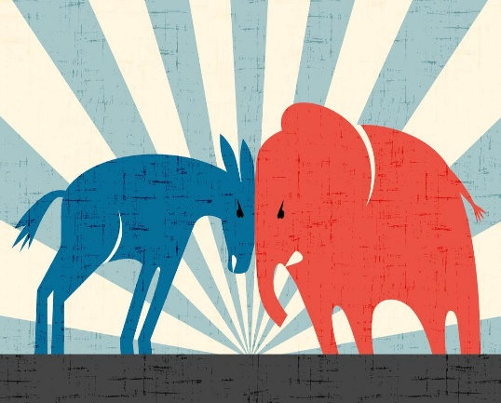

**Partisan Interactions**

We conducted a field experiment with 92,000 contributors to the Democrat and Republican candidates in the 2012 presidential election. We provide causal evidence that individuals feel pressure to agree with the political views of their neighbors and show that these partisan interactions exacerbate geographic polarization.

Perez-Truglia, R. and Cruces, G. (2017). Partisan Interactions: Evidence from a Field Experiment in the United States. Journal of Political Economy, Vol. 125 (4), pp. 1208–1243.

[[Link]](http://www.journals.uchicago.edu/doi/full/10.1086/692711)  [[PDF]](https://www.ocf.berkeley.edu/~pereztruglia/assets/partisan_interactions.pdf)  [[Slides]](https://www.ocf.berkeley.edu/~pereztruglia/assets/Slides_Partisan_Interactions.pdf)

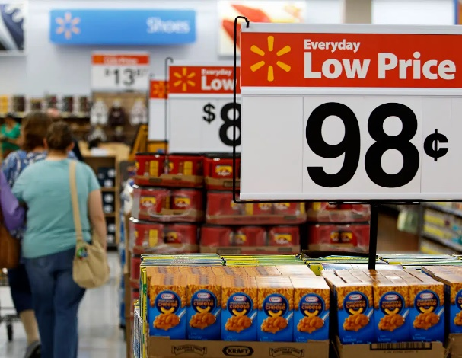**Inflation Expectations and Supermarket Prices**

We use survey and field experiments to study the sources of information frictions for inflation expectations. We show that rational inattention explains some of the misperceptions. However, cognitive limitations appear to play a significant role too: even when information about inflation statistics is available, households still place a significant weight on inaccurate sources of information, such as their memories of the supermarket prices.

Cavallo, A.; Cruces, G. and Perez-Truglia, R. (2017). Inflation Expectations, Learning and Supermarket Prices: Evidence from Field Experiments. American Economic Journal: Macroeconomics, Vol. 9 (3), pp. 1–35.

[[Link]](http://pubs.aeaweb.org/doi/pdfplus/10.1257/mac.20150147)  [[PDF]](https://www.ocf.berkeley.edu/~pereztruglia/assets/inflation_expectations.pdf)  [[Slides]](https://www.ocf.berkeley.edu/~pereztruglia/assets/Slides_Inflation_Expectations.pdf)  [[Questionnaire]](https://www.ocf.berkeley.edu/~pereztruglia/assets/inflation_questionnaire.pdf)

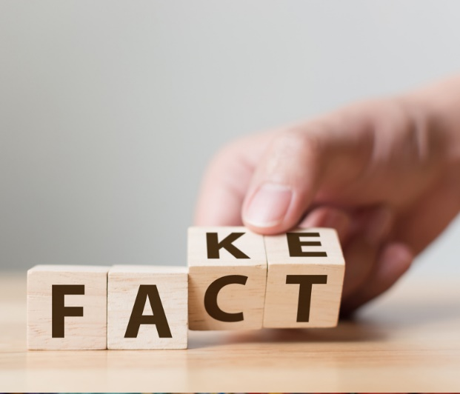**Learning from Potentially Biased Statistics**

We study how individuals learn from potentially biased statistics, using a natural experiment and a survey experiment. We examine a period (2007–15) when the government of Argentina was manipulating official inflation statistics. We provide evidence that, rather than ignoring biased statistics or naively accepting them, households react in a sophisticated way, as predicted by a Bayesian learning model.

Cavallo, A.; Cruces, G. and Perez-Truglia, R. (2016). Learning from Potentially Biased Statistics. Brookings Papers on Economic Activity, Spring 2016, pp. 59-108.

[[PDF]](https://www.brookings.edu/wp-content/uploads/2016/03/cavallotextspring16bpea.pdf)

**Conveniently Upset**

We provide evidence of self-serving biases in other-regarding behavior: people’s beliefs about others are affected by their own desire to be selfish and that ambiguity about other people’s actions plays an important role in allowing selfish behavior. We designed a laboratory game (the “corruption game”) to study this phenomenon.

Di Tella, R., Perez-Truglia, R., Babino, A., Sigman, M. (2015). Conveniently Upset: Avoiding Altruism by Distorting Beliefs About Others’ Altruism. American Economic Review, Vol. 105 (11), pp. 3416-42.

[[Link]](https://www.aeaweb.org/atypon.php?return_to=/doi/pdfplus/10.1257/aer.20141409&etoc=1)  [[PDF]](https://www.ocf.berkeley.edu/~pereztruglia/assets/conveniently_upset.pdf)  [[Questionnaire]](https://www.ocf.berkeley.edu/~pereztruglia/assets/conv_upset_questionnaire.pdf) [[Older Version]](http://www.nber.org/papers/w16645)

**Losing my Religion**

We study the effects of the U.S. Catholic clergy abuse scandals. To estimate the causal effects, we conduct an event-study analysis that exploits the fine distribution of the scandals over space and time. We show that each scandal causes a significant and long-lasting decline in religious participation in the community in which it occurs. The scandals caused a large and long-lasting decline in charitable contributions.

Bottan, N. and Perez-Truglia, R. (2015). Losing my Religion: The Effects of Religious Scandals on Religious Participation and Charitable Giving. Journal of Public Economics, Vol. 129, pp. 106–119.

[[Link]](http://dx.doi.org/10.1016/j.jpubeco.2015.07.008)  [[PDF]](https://www.ocf.berkeley.edu/~pereztruglia/assets/losing_my_religion.pdf)  [[Slides]](https://www.ocf.berkeley.edu/~pereztruglia/assets/Slides_Losing_My_Religion.pdf)  [[Videos]](https://www.ocf.berkeley.edu/~pereztruglia/scandals.html)

**Biased Perceptions of the Relative Income**

What determines the demand for redistribution? Reality or perceptions? We show that there is a middle class bias: rich individuals under-estimate their own rank in the income distribution while poor individuals over-estimate their own rank. We show that those biases arise because individuals naively extrapolate information from endogenous reference groups. We use an information-provision experiment to show that correcting these misperceptions has a significant effect on the demand for redistribution.

Cruces, G., Perez-Truglia, R. and Tetaz, Martin (2013). Biased Perceptions of Income Distribution and Preferences for Redistribution: Evidence from a Survey Experiment. Journal of Public Economics, Vol. 98, pp. 100-112.

[[Link]](http://dx.doi.org/10.1016/j.jpubeco.2012.10.009)  [[PDF]](https://www.ocf.berkeley.edu/~pereztruglia/assets/biased_perceptions.pdf)

## Other Publications

Montano-Campos, F. and Perez-Truglia, R. (2019). **Giving to Charity to Signal Smarts.** Journal of Behavioral and Experimental Economics, Vol. 78, pp. 193-199. [[Link]](https://doi.org/10.1016/j.socec.2018.08.004)  [[PDF]](https://www.ocf.berkeley.edu/~pereztruglia/assets/giving_to_charity.pdf)

Bergolo, M.; Ceni, R.; Cruces, G.; Giaccobasso, M.; Perez-Truglia, R. (2018). **Misperceptions About Tax Audits.** American Economic Association P&P, Vol. 108, pp. 83–87. [[Link]](https://pubs.aeaweb.org/doi/pdf/10.1257/pandp.20181039)  [[PDF]](https://www.ocf.berkeley.edu/~pereztruglia/assets/misperceptions_about_tax_audits.pdf)

Perez-Truglia, R. (2018). **Markets, Trust and Cultural Biases: Evidence from eBay.** Journal of Behavioral and Experimental Economics, Vol. 72, pp. 17–27. [[Link]](https://doi.org/10.1016/j.socec.2017.11.004)  [[PDF]](https://www.ocf.berkeley.edu/~pereztruglia/assets/markets_trust_and_cultural_biases.pdf)

Perez-Truglia, R. (2015). **A Samuelsonian Validation Test for Happiness Data.** Journal of Economic Psychology, Vol. 49, pp. 74–83. [[Link]](http://dx.doi.org/10.1016/j.joep.2015.05.002)  [[PDF]](https://www.ocf.berkeley.edu/~pereztruglia/assets/samuelsonian_validation.pdf)

Galiani, S. and Perez-Truglia, R. (2013). **School Management in Developing Countries.** in P. Glewwe (Ed.), Education Policy in Developing Countries. Chicago: University of Chicago Press. [[Order Book]](http://press.uchicago.edu/ucp/books/book/chicago/E/bo16835736.html)  [[PDF]](https://www.ocf.berkeley.edu/~pereztruglia/assets/school_management.pdf)

Perez-Truglia, R. (2013). **A Test of the Conspicuous-Consumption Model Using Subjective Well-Being Data.** Journal of Socio-Economics , Vol. 45, pp. 146–154. [[Link]](http://www.sciencedirect.com/science/article/pii/S1053535713000905)  [[PDF]](https://www.ocf.berkeley.edu/~pereztruglia/assets/test_of_conspicuous_consumption.pdf)

Perez-Truglia, R. (2012). **On the Causes and Consequences of Hedonic Adaptation.** Journal of Economic Psychology, Vol. 33, pp. 1182-1192. [[Link]](http://dx.doi.org/10.1016/j.joep.2012.08.004)  [[PDF]](https://www.ocf.berkeley.edu/~pereztruglia/assets/hedonic_adaptation.pdf)

Bottan, N. and Perez-Truglia, R. (2011). **Deconstructing the Hedonic Treadmill.** Journal of Socio-Economics, Vol. 40, pp. 224-236. [[Link]](https://www.sciencedirect.com/science/article/pii/S1053535711000084)  [[PDF]](https://www.ocf.berkeley.edu/~pereztruglia/assets/deconstructing_the_hedonic_treadmill.pdf)